**Database Project Part 1**

Submitted by:

Yazeed Alkhalaf – 202211123

Mohammed Kahtan - 202211146

Submitted to:

Dr. Jawad Berri

Course:

Introduction to Database Systems

CIS 221

Submission Date:

Wed 25 Oct, 2023

**README**

**# Database Project Part 1 🚀**

Our goal is to create a software renting company database.

**## Who made this?**

- Yazeed AlKhalaf - @YazeedAlKhalaf - 202211123

- Mohammed Kahtan - @Mohammed-bu - 202211146

**## Notes**

- The derived attribute `number_of_accounts` in `software_resource` would better be computed on the fly instead of saving it in the table. That is because it can be derived by counting the number of records in the `rents` relationship that are related to the `software_resource` and its `rent_period` is still active and didn’t expire.

- The `contact_information` composite attribute attributes were represented as separate attributes since the modern relational databases don’t support composite attributes, but they are represented as composite in the ER diagram. When we translate it to the Relational Model, we need to split it to its basic parts.

- `rent_period` in the `rents` relation on its own can’t tell us when the rent ends since we don’t know when it started. We need to know when it started to calculate that. So, we decided to use two properties instead of `rent_period` to be able to know when it ends accurately. The two properties are:

- `start_date`

- `end_date`

**Here is the ER diagram:**

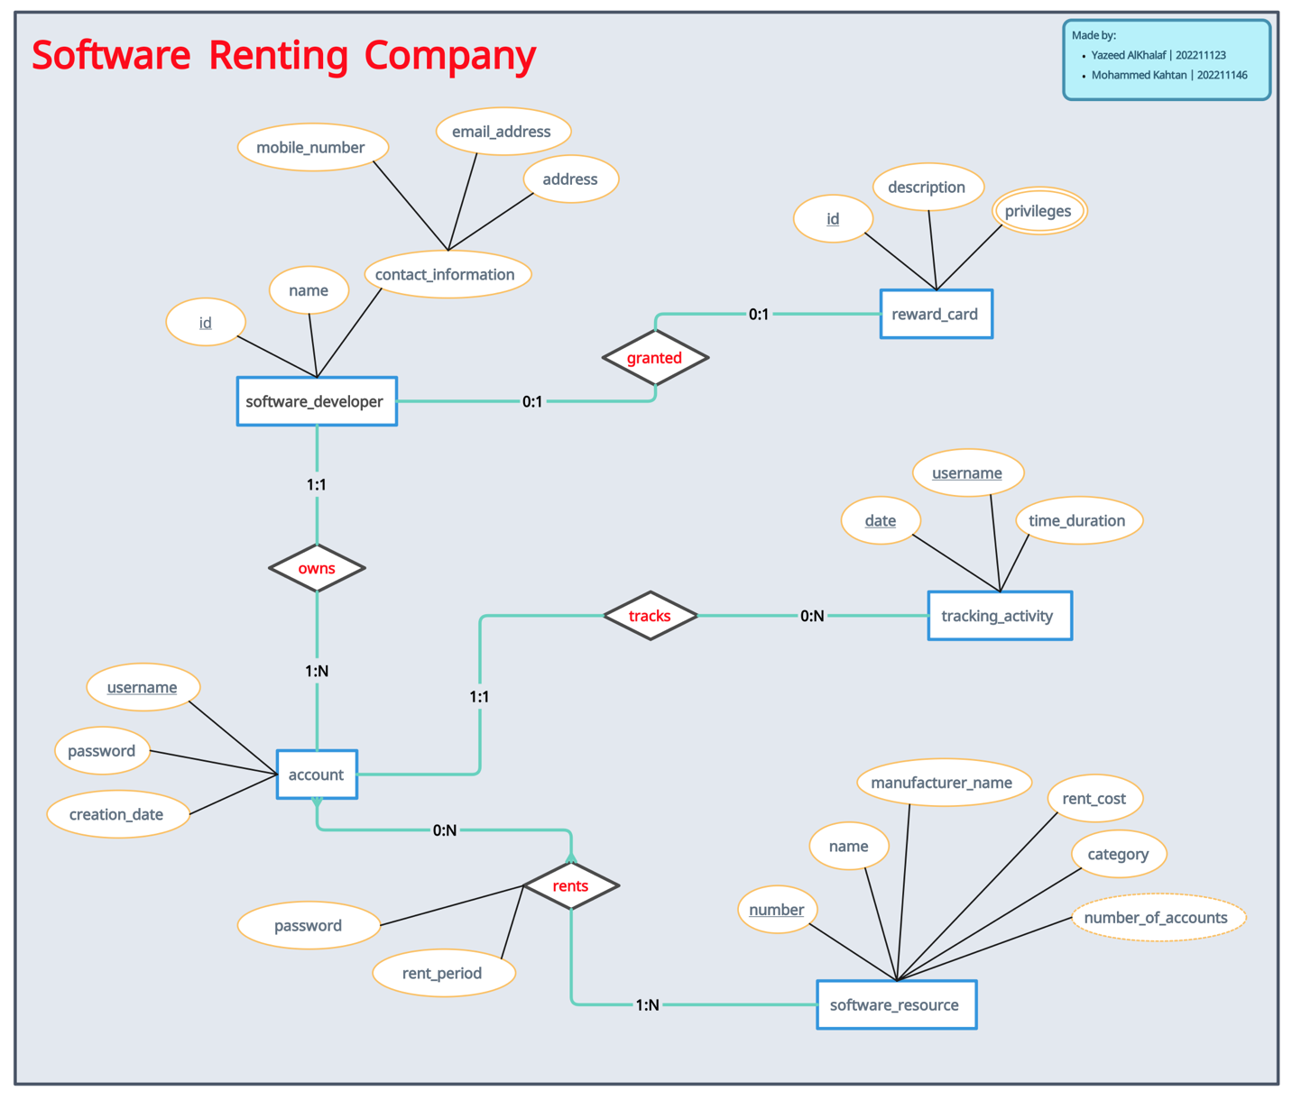

**Here is the MySQL Workbench Diagram:**

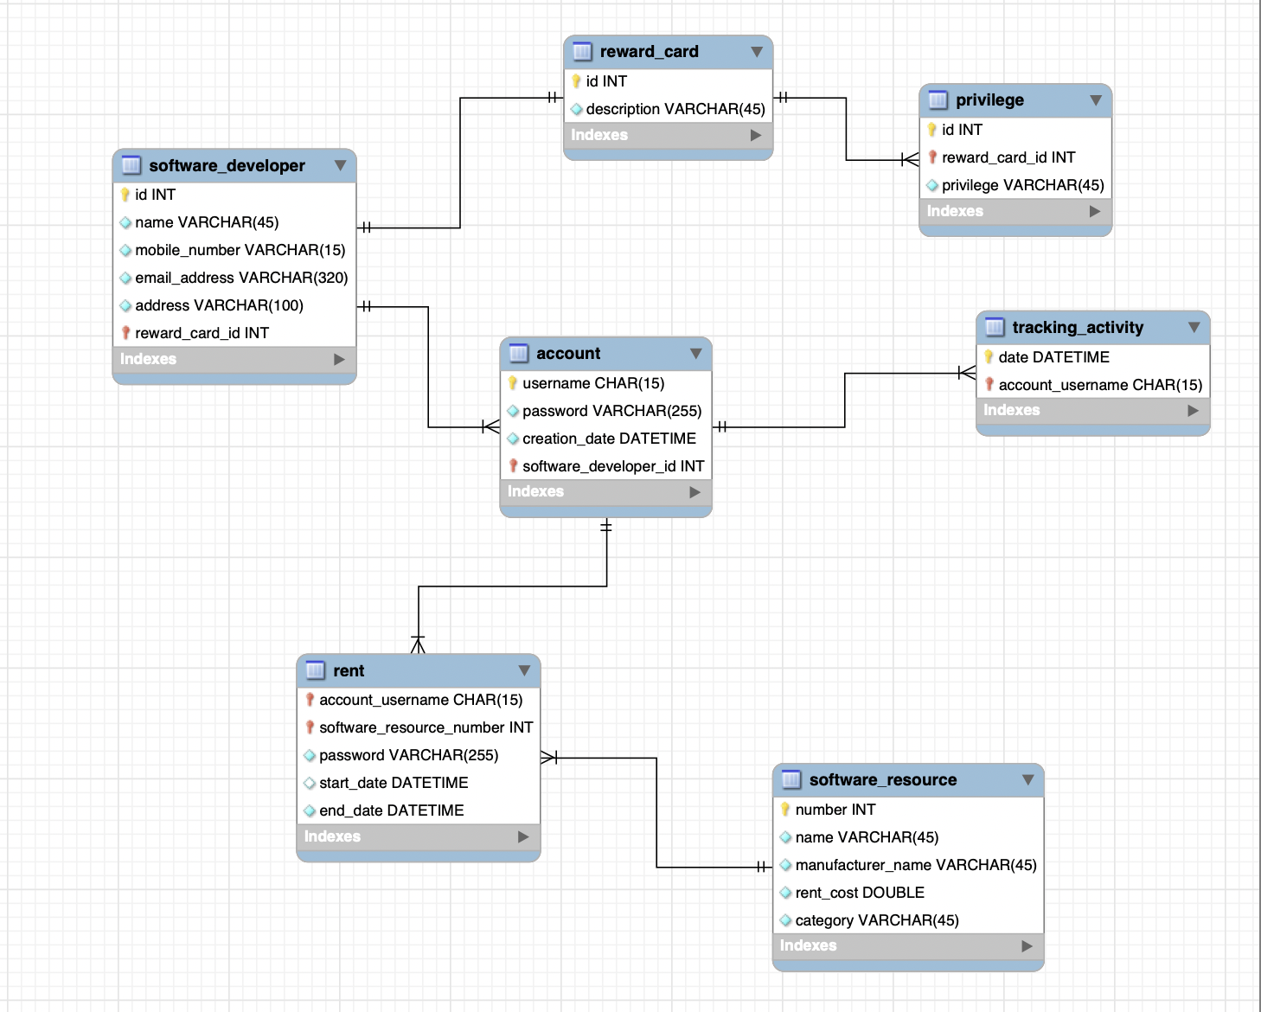

**Here is Forward Engineering Code:**

-- MySQL Workbench Forward Engineering

SET @OLD_UNIQUE_CHECKS=@@UNIQUE_CHECKS, UNIQUE_CHECKS=0;

SET @OLD_FOREIGN_KEY_CHECKS=@@FOREIGN_KEY_CHECKS, FOREIGN_KEY_CHECKS=0;

SET @OLD_SQL_MODE=@@SQL_MODE, SQL_MODE='ONLY_FULL_GROUP_BY,STRICT_TRANS_TABLES,NO_ZERO_IN_DATE,NO_ZERO_DATE,ERROR_FOR_DIVISION_BY_ZERO,NO_ENGINE_SUBSTITUTION';

-- -----------------------------------------------------

-- Schema mydb

-- -----------------------------------------------------

-- -----------------------------------------------------

-- Schema mydb

-- -----------------------------------------------------

CREATE SCHEMA IF NOT EXISTS `mydb` DEFAULT CHARACTER SET utf8 ;

USE `mydb` ;

-- -----------------------------------------------------

-- Table `mydb`.`reward_card`

-- -----------------------------------------------------

CREATE TABLE IF NOT EXISTS `mydb`.`reward_card` (

`id` INT NOT NULL,

`description` VARCHAR(45) NOT NULL,

PRIMARY KEY (`id`))

ENGINE = InnoDB;

-- -----------------------------------------------------

-- Table `mydb`.`software_developer`

-- -----------------------------------------------------

CREATE TABLE IF NOT EXISTS `mydb`.`software_developer` (

`id` INT NOT NULL,

`name` VARCHAR(45) NOT NULL,

`mobile_number` VARCHAR(15) NOT NULL,

`email_address` VARCHAR(320) NOT NULL,

`address` VARCHAR(100) NOT NULL,

`reward_card_id` INT NOT NULL,

PRIMARY KEY (`id`, `reward_card_id`),

INDEX `fk_software_developer_reward_card1_idx` (`reward_card_id` ASC) VISIBLE,

CONSTRAINT `fk_software_developer_reward_card1`

FOREIGN KEY (`reward_card_id`)

REFERENCES `mydb`.`reward_card` (`id`)

ON DELETE NO ACTION

ON UPDATE NO ACTION)

ENGINE = InnoDB;

-- -----------------------------------------------------

-- Table `mydb`.`privilege`

-- -----------------------------------------------------

CREATE TABLE IF NOT EXISTS `mydb`.`privilege` (

`id` INT NOT NULL,

`reward_card_id` INT NOT NULL,

`privilege` VARCHAR(45) NOT NULL,

PRIMARY KEY (`id`, `reward_card_id`),

INDEX `fk_privilege_reward_card_idx` (`reward_card_id` ASC) VISIBLE,

CONSTRAINT `fk_privilege_reward_card`

FOREIGN KEY (`reward_card_id`)

REFERENCES `mydb`.`reward_card` (`id`)

ON DELETE NO ACTION

ON UPDATE NO ACTION)

ENGINE = InnoDB;

-- -----------------------------------------------------

-- Table `mydb`.`account`

-- -----------------------------------------------------

CREATE TABLE IF NOT EXISTS `mydb`.`account` (

`username` CHAR(15) NOT NULL,

`password` VARCHAR(255) NOT NULL,

`creation_date` DATETIME NOT NULL,

`software_developer_id` INT NOT NULL,

PRIMARY KEY (`username`, `software_developer_id`),

INDEX `fk_account_software_developer1_idx` (`software_developer_id` ASC) VISIBLE,

CONSTRAINT `fk_account_software_developer1`

FOREIGN KEY (`software_developer_id`)

REFERENCES `mydb`.`software_developer` (`id`)

ON DELETE NO ACTION

ON UPDATE NO ACTION)

ENGINE = InnoDB;

-- -----------------------------------------------------

-- Table `mydb`.`software_resource`

-- -----------------------------------------------------

CREATE TABLE IF NOT EXISTS `mydb`.`software_resource` (

`number` INT NOT NULL,

`name` VARCHAR(45) NOT NULL,

`manufacturer_name` VARCHAR(45) NOT NULL,

`rent_cost` DOUBLE NOT NULL,

`category` VARCHAR(45) NOT NULL,

PRIMARY KEY (`number`))

ENGINE = InnoDB;

-- -----------------------------------------------------

-- Table `mydb`.`rent`

-- -----------------------------------------------------

CREATE TABLE IF NOT EXISTS `mydb`.`rent` (

`account_username` CHAR(15) NOT NULL,

`software_resource_number` INT NOT NULL,

`password` VARCHAR(255) NOT NULL,

`start_date` DATETIME NULL DEFAULT NOW(),

`end_date` DATETIME NOT NULL,

PRIMARY KEY (`account_username`, `software_resource_number`),

INDEX `fk_account_has_software_resource_software_resource1_idx` (`software_resource_number` ASC) VISIBLE,

INDEX `fk_account_has_software_resource_account1_idx` (`account_username` ASC) VISIBLE,

CONSTRAINT `fk_account_has_software_resource_account1`

FOREIGN KEY (`account_username`)

REFERENCES `mydb`.`account` (`username`)

ON DELETE NO ACTION

ON UPDATE NO ACTION,

CONSTRAINT `fk_account_has_software_resource_software_resource1`

FOREIGN KEY (`software_resource_number`)

REFERENCES `mydb`.`software_resource` (`number`)

ON DELETE NO ACTION

ON UPDATE NO ACTION)

ENGINE = InnoDB;

-- -----------------------------------------------------

-- Table `mydb`.`tracking_activity`

-- -----------------------------------------------------

CREATE TABLE IF NOT EXISTS `mydb`.`tracking_activity` (

`date` DATETIME NOT NULL,

`account_username` CHAR(15) NOT NULL,

PRIMARY KEY (`date`, `account_username`),

INDEX `fk_tracking_activity_account1_idx` (`account_username` ASC) VISIBLE,

CONSTRAINT `fk_tracking_activity_account1`

FOREIGN KEY (`account_username`)

REFERENCES `mydb`.`account` (`username`)

ON DELETE NO ACTION

ON UPDATE NO ACTION)

ENGINE = InnoDB;

SET SQL_MODE=@OLD_SQL_MODE;

SET FOREIGN_KEY_CHECKS=@OLD_FOREIGN_KEY_CHECKS;

SET UNIQUE_CHECKS=@OLD_UNIQUE_CHECKS;